|  |
| --- |
|  |
| SDA Project |
| Saud && FA22-BSE-047 |
|  |
|  |
| **11/2/2024** |

|  |
| --- |
|  |

**USE CASE**

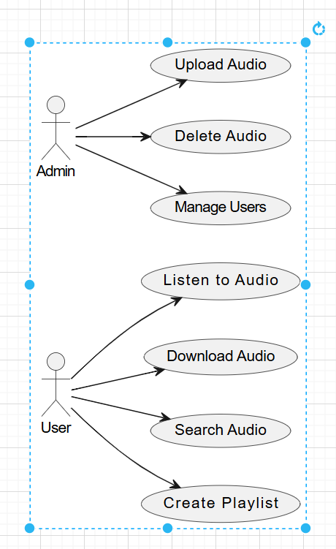

**Fully DressedCase for Uploading Audio**

**Use Case: Upload Audio**

**Use Case ID**:  
UC6

**Use Case Name**:  
Upload Audio

**Actors**:

* **Primary Actor**: Admin
* **Secondary Actor**: System

**Stakeholders and Interests**:

* **Admin**: Wants to upload audio files to make them available to users.
* **System**: Needs to manage file uploads securely, store files and metadata efficiently, and verify admin permissions.

**Preconditions**:

* The Admin is registered, authenticated, and logged into the system.
* The Admin has the necessary permissions to upload audio content.
* The audio file format is supported, and the file size is within the allowed limit.

**Postconditions**:

* The audio file and metadata are stored in the system.
* The newly uploaded audio is available in the library for users to access.

**Main Success Scenario:**

1. **Admin** navigates to the audio upload section in the admin interface.
2. **Admin** selects the option to upload a new audio file.
3. **System** prompts the Admin to select the audio file and provide metadata (e.g., title, artist, genre).
4. **Admin** selects the audio file from their device and enters the required metadata.
5. **System** verifies the file format, file size, and metadata completeness.
6. **System** stores the audio file in designated storage and saves the metadata in the database.
7. **System** confirms the successful upload and displays the uploaded audio entry to the Admin.

**Extensions:**

* **3a. File Format is Unsupported**:
  + **3a1**. The **System** detects an unsupported file format.
  + **3a2**. The **System** displays an error message, specifying the acceptable file formats.
  + **3a3**. The **Admin** may upload a supported format or cancel the upload.
* **4a. Metadata Validation Fails**:
  + **4a1**. Required metadata fields are incomplete or invalid.
  + **4a2**. The **System** displays an error, indicating the missing or incorrect fields.
  + **4a3**. The **Admin** corrects the metadata and resubmits the upload.

**SSD**

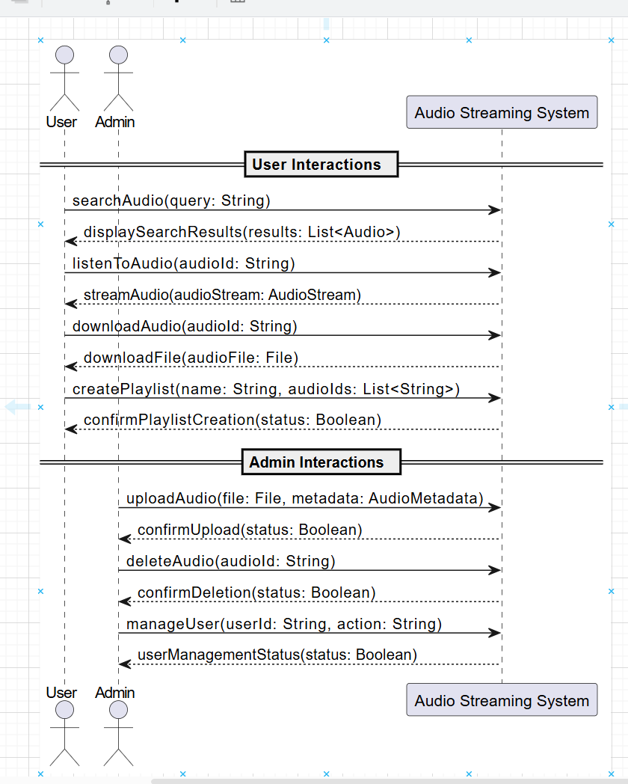

**Class Diagram**

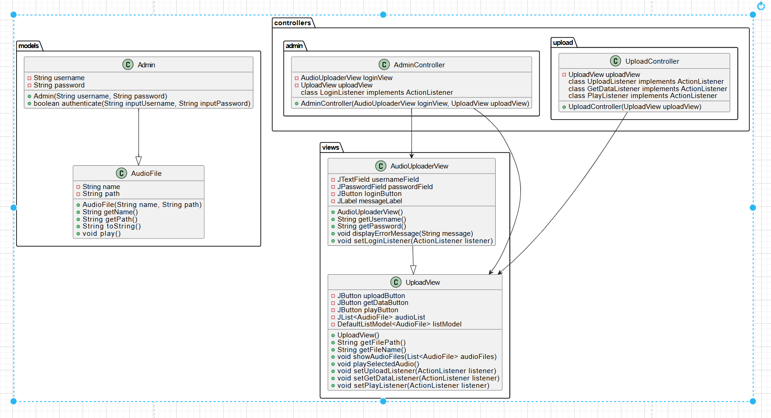

**Package Diagram**

